Introduction to the International Chemical Identifier (InChI )

Martin A Walker
State University of New York at Potsdam
walkerma@potsdam.edu

This module provides students with an introduction to chemical identifiers in general, and the InChI in particular. It is aimed at students who are beginning their study of organic chemistry, and it can be used at the same point as where IUPAC naming rules are introduced.

Student learning objectives

Upon completion of this unit, students should be able to:
- Understand the different ways of representing a chemical structure or compound (and their uses and differences), viz., Lewis structures, skeletal structures, IUPAC names, InChI strings and keys, CAS Registry Numbers, SMILES.
- Understand the concept of an InChI String and explain its basic layout, then apply this to generation of InChI and identification of a particular molecular structure.
- Understand the structure, generation, retrieval and use of an InChIKey, then apply this to Internet–based structure searches.

Last updated July 28, 2019
This InChI OER is licensed under CC-BY 4.0
https://creativecommons.org/licenses/by/4.0/

Representing a chemical structure

Chemical structures are the essential building blocks in organic chemistry. They make up the “words” of every organic chemistry sentence, so it is vital to understand how to read and write structures. Chemical structures are usually represented by the skeletal formula, which provides a graphical representation of the molecule with most hydrogens omitted for clarity. Full Lewis structures are used only rarely, when a more complete representation is needed. But sometimes structures need to be represented in other ways, such as a name or other identifier. Fig. 1 illustrates some of the most common representations for 1-bromobutane.

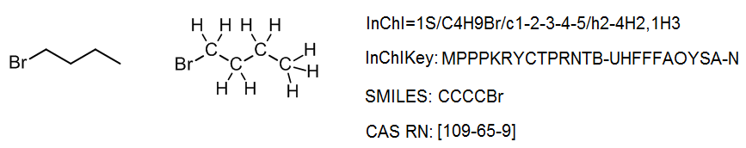
Fig. 1: Representations of 1–bromobutane: Skeletal structure, Lewis–type structure, InChI string, InChIKey, SMILES and CAS Registry Number.

IUPAC Name

Traditionally, a chemical name was essential when a non–graphical representation was needed, for example in a chemical catalogue or handbook. In law, a chemical is often still represented by a name rather than a structure. As a result, a set of rules has been developed to provide any structure with a systematic name. These rules have been approved by chemistry’s governing body, the International Union of Pure and Applied Chemistry (IUPAC), and are now well–established in chemistry publications. This ensures that when chemists communicate information through text, they can be certain they are referring to the same chemical structure. The main nomenclature rules can be found online in the IUPAC Blue Book, and in any modern textbook on organic chemistry.

Computer–based identifiers

Once computers began to be used to store chemical information, it became necessary to design identifiers for chemical substances. Although structures can be drawn on computer, most structures being published in 2019 are simply image files, in which the chemical information cannot easily be read by computer. Most structure drawing software allows the user to save the structure as a Molfile, which contains the structure in a computer-readable table format suitable for chemical databases, etc. Nevertheless, many saw a need for a more concise way to represent chemical structures for computers in a single string (line of characters). These can be divided into “registry lookup” identifiers, which are in effect the listing number in a database (with no intrinsic chemical information), and “linear notations” which encapsulate the structural information in a single string.

Since 1965, Chemical Abstracts Service (CAS) has allocated “registry lookup” identifiers, called CAS Registry Numbers, for every substance in its database. Each number is unique for a given substance. The number is assigned by CAS and does not contain structural information in the number; as such, it represents an actual substance (usually one that has been reported in the literature) rather than a structure (which may be only theoretical). CAS Registry Numbers are now used widely outside CAS as substance identifiers, for example in the US government list of “Chemicals of Interest” for Homeland Security.

Other identifiers were then developed based on line notations that encoded structural information in the identifier. One important such identifier is SMILES, developed in the 1980s as a machine-readable format that is “human-friendly”; simple structures can easily be read from a SMILES string either by a a computer or a trained chemist.

International Chemical Identifier (InChI)

The most important of structural representation for computers is the InChI, which is also considered by IUPAC to be the “official” machine representation. Although it was only published first in 2005, it quickly became established as a valuable way to communicate structural information via the internet.⁷ Unlike many identifiers, the InChI algorithm is available for use under an open copyright, so that it can be freely generated and used without risk of copyright violation.

It is not important for a scientist to know how to read or write an InChI from scratch; any chemical drawing program can perform this task with ease. However, it is instructive to understand how the InChI is constructed, and how to use it. Consider a simple structure such as 2-bromobutane, which has the structure and InChI shown below:

The InChI is a string of characters that uses a series of “layers” to indicate various levels of structural detail. In this way, chemists can communicate information at the appropriate level of detail. Every InChI starts with “InChI=” followed by the version number, which in this case is version 1. The “S” indicates that the InChI is “standard” and does not include any optional information. The rest of the InChI is organized in layers, where each layer starts with a forward slash “/”. These sub-layers show: chemical formula, atom connections (beginning with /c), and hydrogen atoms (beginning with /h). For example, for 2-bromobutane, we have:
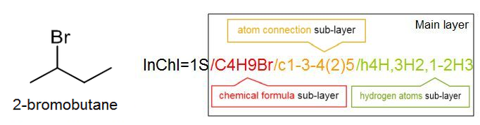

In some cases we may want to indicate a higher level of detail, for example the 3D–orientation of the atoms or stereochemistry. For this we use an additional layer at the end, in this case the stereochemistry layer (beginning with /t, /m and /s), to give an InChI which is unique for that specific stereoisomer:

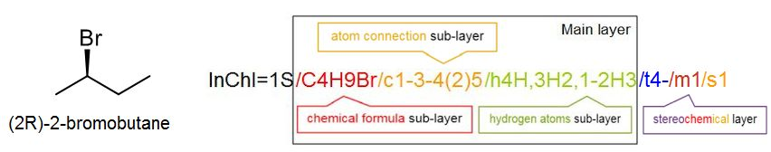

One useful aspect of this layered structure is that similar structures have similar InChIs. For example, all isomers with the formula C₄H₉Br will begin with C4H9Br in the chemical formula sub-layer; in a database, these isomers can be easily identified. Likewise, two stereoisomers will have the same main layer, and only differ in the stereochemical layer. Many simple organic compounds will have just the main layer in their InChI.

An InChI of this sort can be found in Wikipedia and most online chemical databases such as PubChem and ChemSpider, where it is considered to be one of the main types of chemical identifier. An InChI can be generated from a chemical structure in most modern structure drawing programs, such as BioviaDraw, ChemDraw, ChemSketch or ChemDoodle. These programs also allow the reverse – to input an InChI and use it to generate a chemical structure.

InChIKey

For larger molecules, the InChIKey can become large and unwieldy, making it difficult to use for certain applications, notably Web searches. Many search engines truncate long search strings, so later characters are lost from the search. For this reason the InChIKey was created, where the InChI (or structure) is converted to a 27 character string (including two dashes) based on a sequence of only upper case letters. The InChIKey is most used for Web searches. For example, the full InChI for morphine is InChI=1S/C17H19NO3/c1-18-7-6-17-10-3-5-13(20)16(17)21-15-12(19)4-2-9(14(15)17)8-11(10)18/h2-5,10-11,13,16,19-20H,6-8H2,1H3/t10-,11+,13-,16-,17-/m0/s1, whereas the InChIKey is simply BQJCRHHNABKAKU-KBQPJGBKSA-N .

This conversion to the InChIKey uses a “hash” function, which scrambles the InChI coding in order to generate an InChIKey that is as close to unique as possible. One unfortunate side effect of this is that once scrambled as the InChIKey, a structure cannot be converted back to an InChI or structure. This in turn means that the structure encoded in an InChIKey can only be found by comparing it against a list of known InChIKeys, known as a “lookup table”. If the InChIKey is for a new or unknown substance, the InChIKey cannot allow the user to identify what the molecule is.

As with the InChI itself, InChIKeys can be generated at will using any standard structure drawing program. Copying the InChIKey into a search engine allows the user to quickly find documents on the Web that relate to that specific structure.

Summary
Chemical structures may be represented in many ways, such as IUPAC names or computer-friendly line notations such as InChI. The InChI embeds the structural information in a series of “layers”, and it can be converted back to the original structure. It is useful for storing chemical structure information in databases. Meanwhile the InChIKey is a hashed version of the InChI which is mainly used to search chemical structures on the Web.

Sources
Contains some contributions taken from “InChI Student Worksheet,” Steven Wathen, CC–BY-4.0, available from https://www.inchi-trust.org .

Questions
Note: Questions for students are shown in bold; suitable answers are shown in italics underneath.

- Why do chemical structures need to be represented in other ways than skeletal structures?

Names are useful for listings such as chemical catalogues, where a searchable alphabetical listing is needed. They may also be used outside chemistry (e.g., in law). Structure identifiers such as InChI and InChIKey are useful for chemical databases and Web searching, where they provide a simple, concise machine-readable way to show chemical information.

- What are the main differences between InChI and a CAS Registry Number (CASRN)?

An InChI is a line notation, meaning that it contains complete structural information for a compound; it can be generated at will in a drawing program, even for a hypothetical structure. In contrast, a CASRN contains no intrinsic chemical information, and it can only be assigned by CAS. For these reasons an InChI can be regarded as representing a structure, whereas a CASRN represents an actual substance (usually one reported in the chemical literature). InChI is recognized as an international standard by IUPAC, available for use under an open copyright, whereas CAS Registry numbers are mainly considered proprietary, though both are used widely.

  - Explain how an InChI is built from a series of “layers”.
  - What layers are used in an InChI for a simple compound such as water?
  - What is the difference between the InChIs for 2-bromobutane with and without 3D stereochemistry? What do the two InChIs have in common?

- What are the main differences between an InChI and an InChIKey? What are the uses for each?

An InChI contains the complete structural information for a molecule, and this information can be retrieved using a standard structure drawing program. It is useful for storing structural information for such things as databases. An InChIKey is a hashed version of the InChI, and the structure cannot be retrieved without the use of a lookup table. The InChIKey is most useful for Web searches.

The remaining questions require students to have access to a structure drawing program, such as BioviaDraw, ChemDraw, ChemSketch or ChemDoodle. Note that the menu options in each program are different, so instructor guidance may be needed.

- This question explores the relationship between the InChI and the chemical structure.
a. Draw a six carbon chain, to represent the alkane hexane (C₆H₁₄). Now generate an InChI from that structure, using the program. What layers are present? What can you tell from the InChI about the structure?
b. Generate an InChIKey for hexane, and use it to search the Web. What do you find?
c. Now attach an oxygen atom to the second carbon from the left to turn the structure into an alcohol. Generate an IUPAC name and generate an InChI for that structure. What can you tell from the InChI about the structure? What differences can you see between this and the InChI from (a)?
d. Now generate an InChIKey for this alcohol, and compare it to the InChIKey you generated for hexane. What is the same, and what is different? Use this InChIKey to search the Web. What do you find?
e. Try generating a structure back again from your alcohol InChI. What do you notice about the structure you just generated, compared to the structure you just made? Is it the same compound?

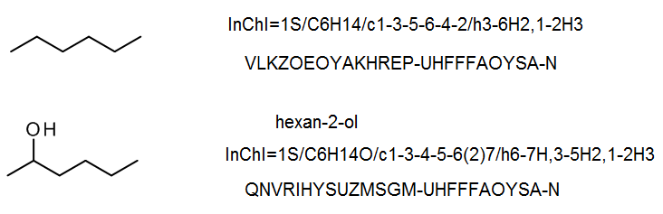
- Only the main structural layer is present. The clearest part of the InChI is the molecular formula, which comes right after the 1S/ (which indicates a version 1 standard InChI). Students may also recognize certain patterns in the later sub–layes, wuch as the 1-2H3 motif.
- This InChIKey will find various web pages containing hexane (often listed as n–hexane), such as PubChem, ChemIDPlus, ChemBL, ChemSpider, etc.
- As before, the clearest part of the InChI is the molecular formula, and the InChI version.
- This InChIKey has the same second part, but a completely different first part. It will find various web pages containing hexan-2-ol, such as PubChem, ChemIDPlus, ChemBL, ChemSpider, etc.
- The structure generated by the software should be the same compound, but it will probably be drawn differently than the original.

- This questions explores generation of a complex structure (coprostanone) from an InChI, as well as searching using the InChI and InChIKey.
a. Copy this InChI into a search engine: InChI=1S/C27H46O/c1-18(2)7-6-8-19(3)23-11-12-24-22-10-9-20-17-21(28)13-15-26(20,4)25(22)14-16-27(23,24)5/h18-20,22-25H,6-17H2,1-5H3/t19-,20-,22+,23-,24+,25+,26+,27-/m1/s1
What do you find?
b. Now copy the corresponding InChIKey: FWVRSACGGAUWNP-BWOONYPSSA-N What do you find for that? Are there some pages in common with a? How are the results different from what you found in a?
c. Try converting the InChI (from a) into a structure using your structure drawing program. Does this work? If so, what structure do you produce, and does it look like the structure given in ChemBL?
d. Try converting your InChIKey (from b) into a structure using your structure drawing program. Does this work? If so, what structure do you produce, and does it look like the structure given in ChemBL?

The structure generated in c should look something like:
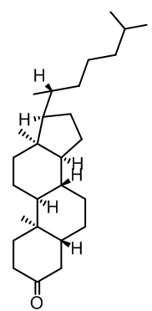
However, the particular program may cause an alternate tautomer to be generated (BioviaDraw gave the above result).
- A Google search (or similar) for the full InChI should find pages in places such as PubChem, ChemSpider and NIST, but these answers are either partial matches or give cholesterol (an isomer) as the (incorrect) answer.
- A Google search (or similar) for the InChIKey should find pages in places such as Toxnet (as ChemIDPlus), ChemSpider and PubChem that refer to coprostanone or 5beta-Cholestan-3-one (the same compound).
- This should work, and produce a correct structure for coprostanone (see above).
- This is impossible. Students can, however, generate a structure by “Googling” the InChIKey and locating structures associated with this InChIKey. This can be a discussion point, once they find that the drawing program is unable to convert an InChIKey to a structure.

http://www.chemspider.com/Chemical-Structure.7711.html?rid=b8719dd4-7de2-4140-aebf-afb809c26dab
http://www.commonchemistry.org/ChemicalDetail.aspx?ref=109-65-9
https://iupac.org/projects/project-details/?project_nr=2001-043-1-800 , accessed
https://www.acdlabs.com/iupac/nomenclature/
https://www.cas.org/about/cas-history
https://www.dhs.gov/cisa/appendix-chemicals-interest
Heller, Stephen R.; McNaught, Alan; Pletnev. Igor; Stein, Stephen; Tchekhovskoi, Dmitrii. “InChI, the IUPAC International Chemical Identifier.” Journal of Cheminformatics, 2015, 7:23.
https://en.wikipedia.org/wiki/Simplified_molecular-input_line-entry_system
Warr, W.A. “Many InChIs and quite some feat” J. Comput. Aided Mol. Des., 2015, 29: 681. https://doi.org/10.1007/s10822-015-9854-3

